**Chapter 4**

**RESULTS AND DISCUSSION**

**4.1 Requirements Specification**

The server installation option chosen for the system is to setup a locally owned web server and publish it to the internet. Costing was the main factor for this decision. This server will then be the main base of operations for the TAMIS.

The option chosen for the sending and receiving of Short Message Service (SMS) alerts in the system were both the first and second. This gives the system flexibility in its method of transacting messages. BulkSMS was chosen for the first option. It is one of the first commercial web based messaging platforms launched globally. It is connected to over 800 Global System for Mobile Communications (GSM) networks in 180 countries.

The reason for choosing this service was because it provides standard platforms to allow any client to quickly deploy any SMS service.

For the second option, the proponents were very fortunate to have been able to borrow, use, and test a fairly expensive SMS gateway server device owned by their thesis adviser. Both the first and second options were successfully incorporated in the system. The Call Center Agent can just choose whichever from the two methods when sending or receiving SMS alerts. This SMS gateway is essential for the TAMIS since it is one of its core functions. A Code sample of the HTTP/S or PHP API is shown below.

Code Sample:

**4.2 Systems Design**

From the analysis and interpretation of the data, sample forms have been gathered for the idea of the requirements involved in traffic accidents. Using the Code Igniter framework, the researchers were able to build the system that has the major modules of SMS alert function, data representation and default function modules.

In the SMS alert module, the researchers were able to broadcast traffic accident reports to the hospitals, traffic officers and police using the SMS gateway. These entities received SMS message containing the description of the traffic accident, name of the person who reported the traffic accident, address of the street where it happened.

In the data representation module, traffic accident reports are stored in the database. These traffic accident reports are handled by the system where the call center agent can update status and reports. Then, website visitors can view the content relating to public knowledge regarding traffic accidents. From the reports stored in the database, data are accumulated to generate reports that can be viewed by the users also through the system.

For the default function modules, the configuration settings between user privileges were implemented. The system admin can save his/her preferred settings, view user information and manage website related data.

**4.3 Programming and Prototyping**

Eclipse for PHP is just another powerful and versatile Integrated Development Environment (IDE), which is an open source application. The proponents will use this because it has rich features in terms of coding in the sense of object-oriented programming, such as outline layout (exposing methods of objects and variables for the ease of navigation from line to line of codes), code hinting, color coding, and many more advanced features.

Adobe Dreamweaver an Integrated Development Environment (IDE) will be used for editing HyperText Markup Language (HTML) for the main reason that it is abundant of features in styling a web page. This can also be used for making and editing other types of scripts like JavaScript, Action Script, PHP, CSS, and ColdFusion. In the context of the development of TAMIS, this will be used for its HTML authoring capabilities, CSS and JavaScript. We will be using it’s free trial version throughout the development.

Adobe Photoshop is the bitmap graphic application to be used for designing the Graphical User Interface (GUI) of the system. This application is a powerful tool for creating web page designs. This application is very helpful on the initial development of the system because it clarifies the output of the system. We will be using the 30-day trial version of this application.

Git is free software distributed under the terms of the GNU General Public License. The use of git in the development of the system is to have repository or working files on a cloud or the internet. The software has a revision control that enables the development team to revert their working files to the desired version of the system.

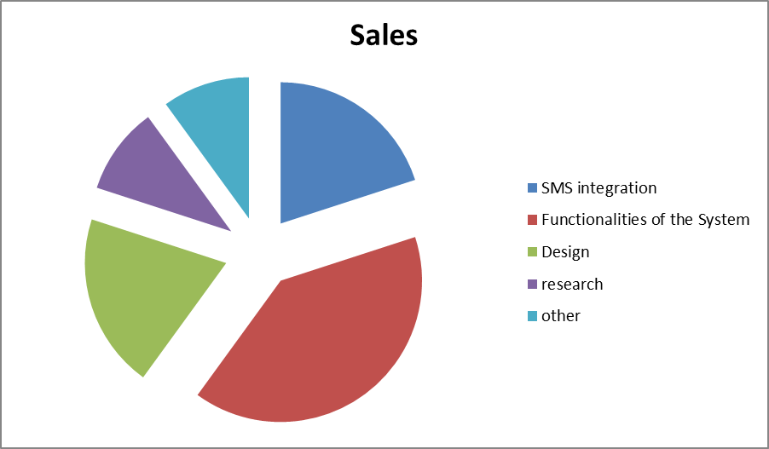

Figure 4.1: Prototyping Chart